Portfolio Optimization: Mean-Variance vs Risk Parity

Author: HARSH BYJASH | Date: 2025-10-01

# 1. Objective

Compare mean-variance optimal portfolios to risk-parity allocation on a multi-asset dataset.

# 2. Data

Synthetic daily prices for 5 assets (Stock A, Stock B, Stock C, Bond, Gold) from 2020–2024.

# 3. Method

Computed annualized mean returns and covariance matrix. Simulated 5,000 random portfolios to trace the efficient frontier. Highlighted max Sharpe ratio portfolio, minimum volatility portfolio, and risk parity allocation (equal risk contribution across assets).

# 4. Results

Efficient frontier shown below. Metrics for selected portfolios:

|  |  |  |  |
| --- | --- | --- | --- |
| Portfolio | Return | Vol | Sharpe |
| Max Sharpe | 16.03% | 13.01% | 1.23 |
| Min Vol | 6.30% | 9.15% | 0.69 |
| Risk Parity | 7.49% | 9.26% | 0.81 |

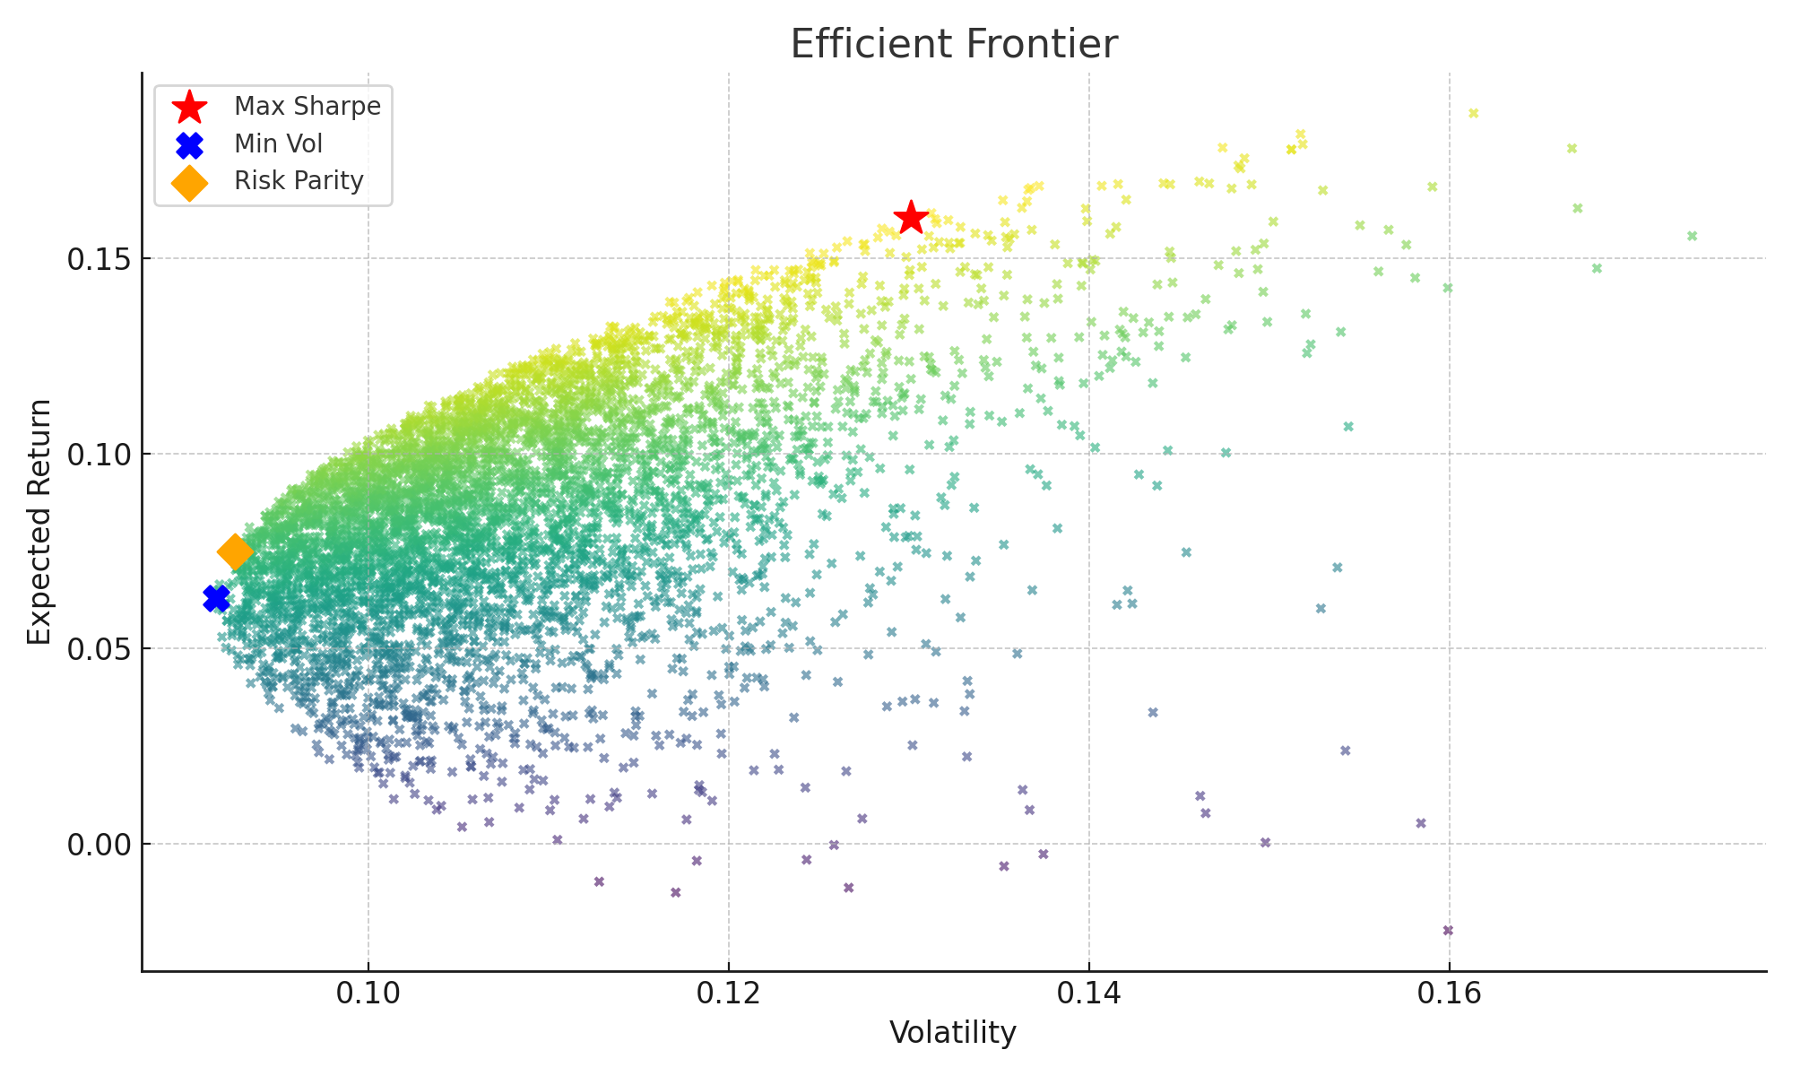

# 5. Interpretation

The max Sharpe portfolio concentrated risk into higher-return assets. The min-vol portfolio held mostly bonds and gold. Risk parity produced balanced exposure, avoiding concentration while achieving moderate Sharpe ratio.

# 6. Limitations

Synthetic data limits realism. In practice, expected returns are highly uncertain; covariances change over time. Transaction costs and constraints (short-selling, leverage) were ignored.

# 7. Next Steps

Extend to rolling-window optimization, include constraints (max weight, no shorting), and test out-of-sample with real market data.